Tucson Reunion
The 20th Tactical Fighter Wing Association reunion will be held in Tucson, Arizona from Thursday October 30, 2025 until Sunday November 2, 2025 at the Desert Diamond Hotel and Casino in Tucson. Please save the dates.
Events featured during the reunion include the Titan Missile Museum on Thursday and the Pima Air and Space Museum on Friday. Shuttle bus transportation will be provided by the hotel. Details on these two venues were previously provided in the summer newsletter.
Golf will be available on Saturday. Those wishing other interesting venues on Saturday or possibly on Wednesday or Sunday if an extended visit is made, may want to visit the Desert Museum and/or Old Tucson.
Desert Museum
The Arizona Sonora Desert Museum, located twelve miles west of Tucson in the Tucson Mountains, is ranked on TripAdvisor.com as one of the Top 10 Museums in the United States. It is the number one Tucson attraction. Unlike most museums, about 85 percent of the experience is outdoors. The 98-acre museum comprises a zoo, botanical garden, art gallery, natural history museum, and aquarium. It includes 21 interpreted acres with two miles of walking paths through various desert habitats, 242 animal species, and 56,000 individual plant specimens. The museum also contains one of the world's most comprehensive regional mineral collections.
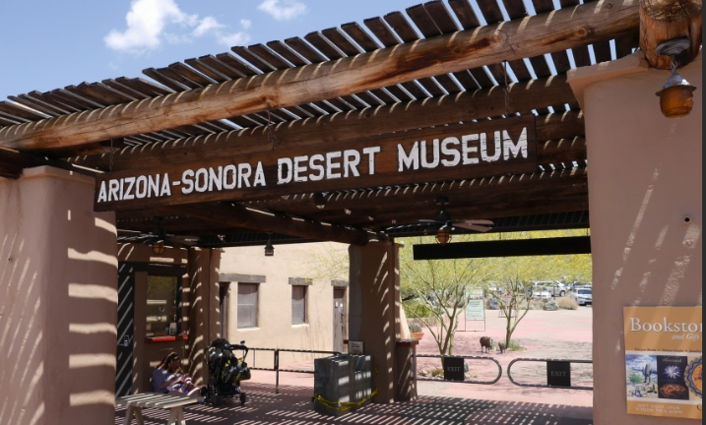
The Arizona-Sonora Desert Museum is widely recognized throughout the world as a model institution for innovative presentation and interpretation of native plants and animals featured together in ecological exhibits. The Museum is regularly listed as one of the top ten zoological parks in the world due to its unique approach in interpreting the complete natural history of the Sonoran Desert and adjacent ecosystems.

Old Tucson Studios
Old Tucson is an American movie studio and theme park just west of Tucson Arizona, adjacent to the Tucson Mountains and close to the western portion of Saguaro National Park. Old Tucson was originally built in 1939 for the movie Arizona released in 1940. It has been used for the filming location of many movies and television westerns since then, such as Gunfight at the O.K. Corral (1957), Rio Bravo (1959), El Dorado (1966),
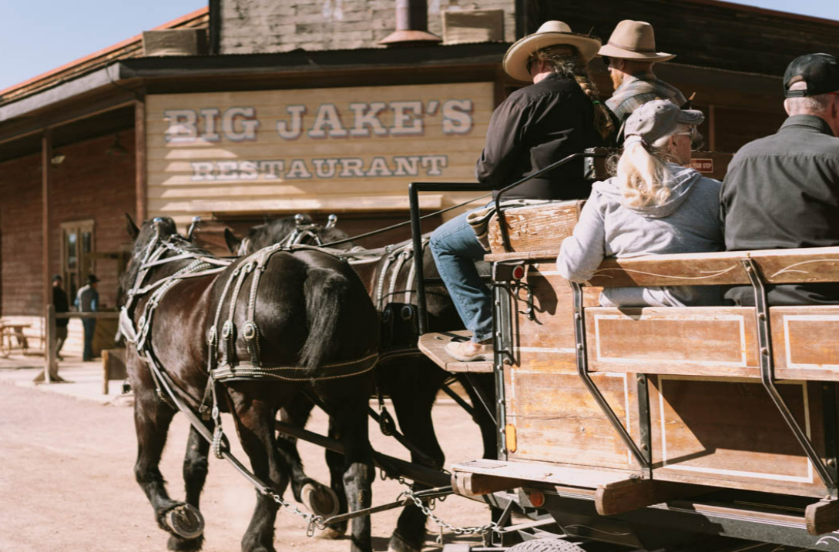
Little House on the Prairie TV series of the 1970s – 1980s, and the popular film Tombstone (1993). It was opened to the public in 1960 as a theme park with historical tours offered about the movies filmed there. It also has live cast entertainment featuring stunt shows, shootouts, can-can shows as well as themed events. It is still a popular filming location used by Hollywood.

